**Feedback and Improvements:**

**Scenario:**

Try to remove the default value under Total Load (KW) or try to input any alphabets and click somewhere in the application

**Expected result:**

System should throw validation error message

**Actual Result:**

System re-directs user to error page and when user clicks on back or re-fresh button page is not recovered

System goes into a deadlock with invalid error path “**ERROR.aspx?aspxerrorpath=”**

https://www.bestundertaking.net/ERROR.aspx?aspxerrorpath=/NewConnection.aspx

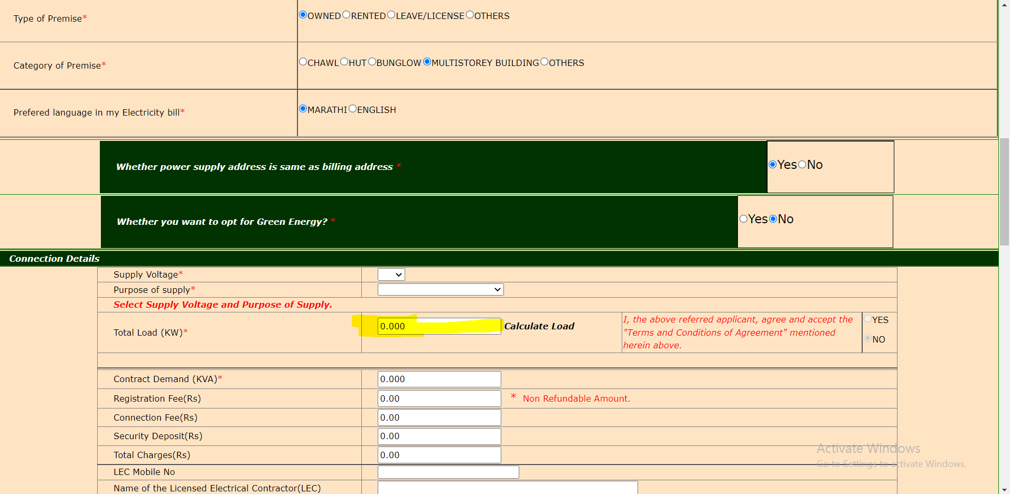

1)

Once photo and signature has been uploaded by the user, we can show this image, it’s not good showing an broken image in UI on Home page.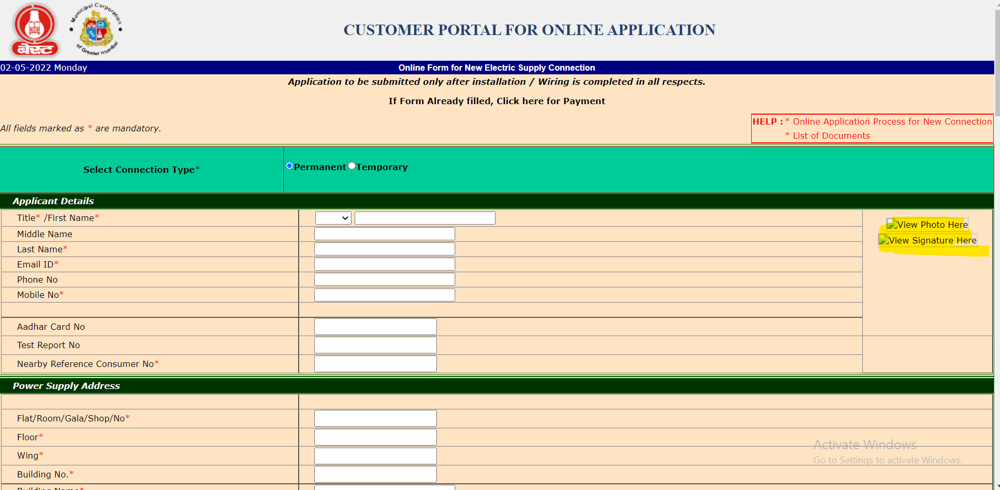

Edge Browser

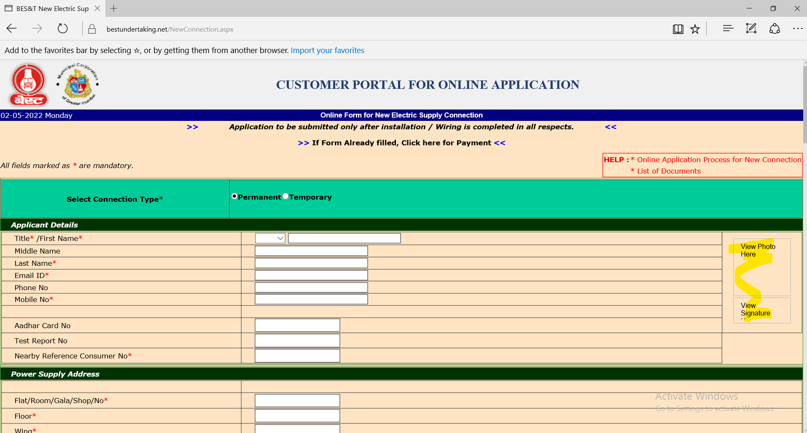

2) Background color “Bisque” of the entire application can be changed as it’s not in sync with the important information displayed in UI and error messages (Red color)

3) Text “**Required**” can be made to be displayed only once in UI for field Title/First Name

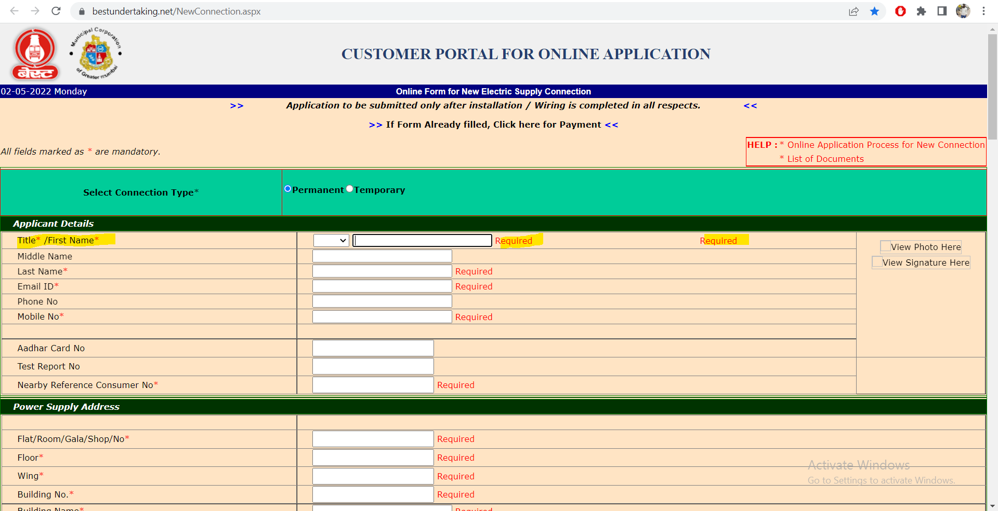

4) Error messages for Upload Photo, upload signature, upload proof and upload identity proof can be displayed in same area for ease of use. Error message are moving from left to right based on user actions

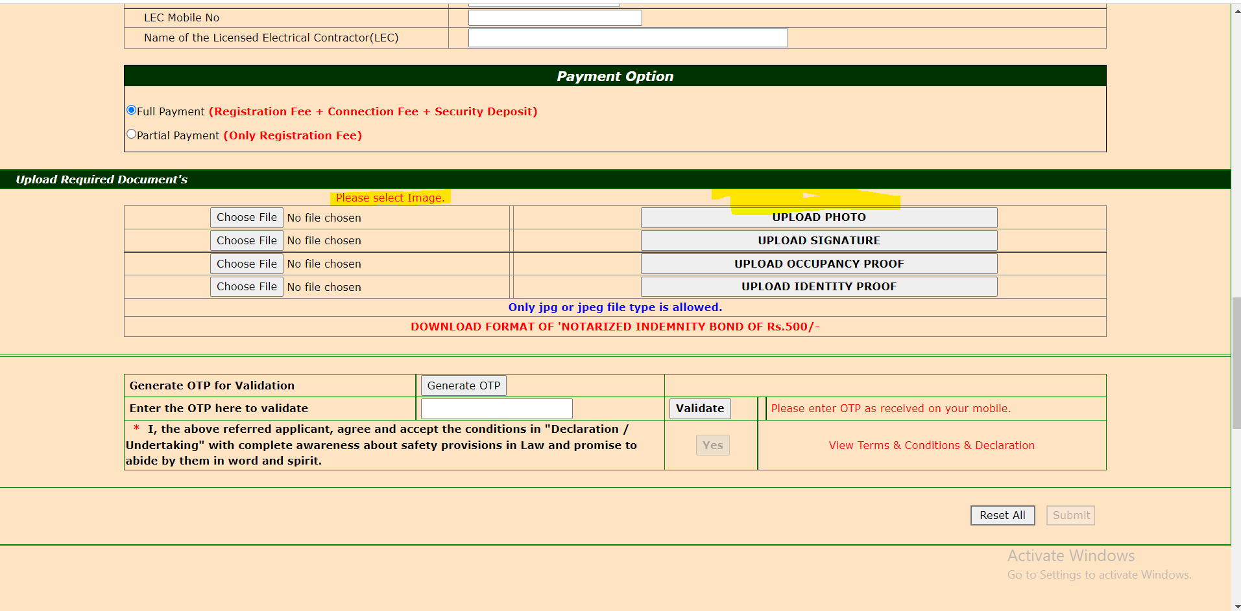

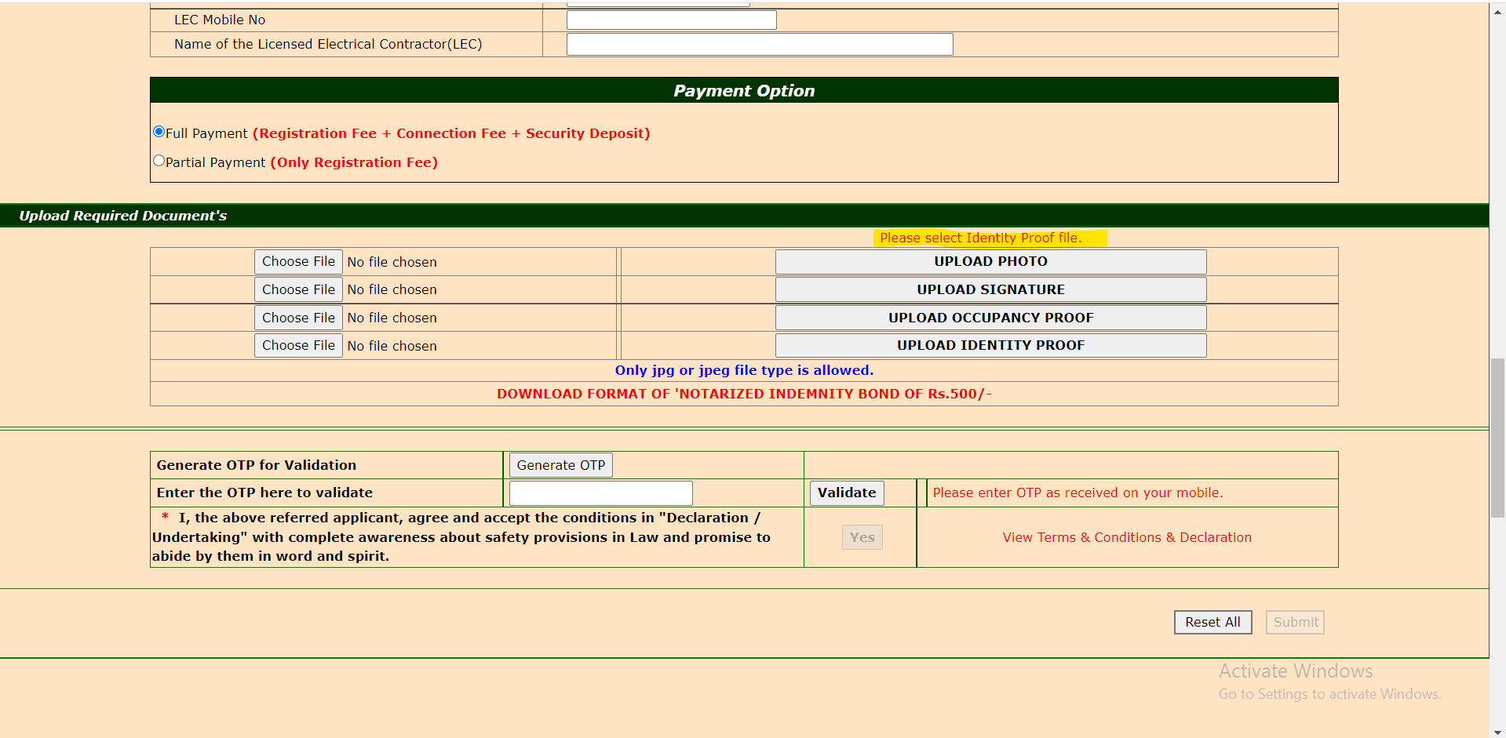

5) Proper page title should be displayed when a new page is invoked from main page.

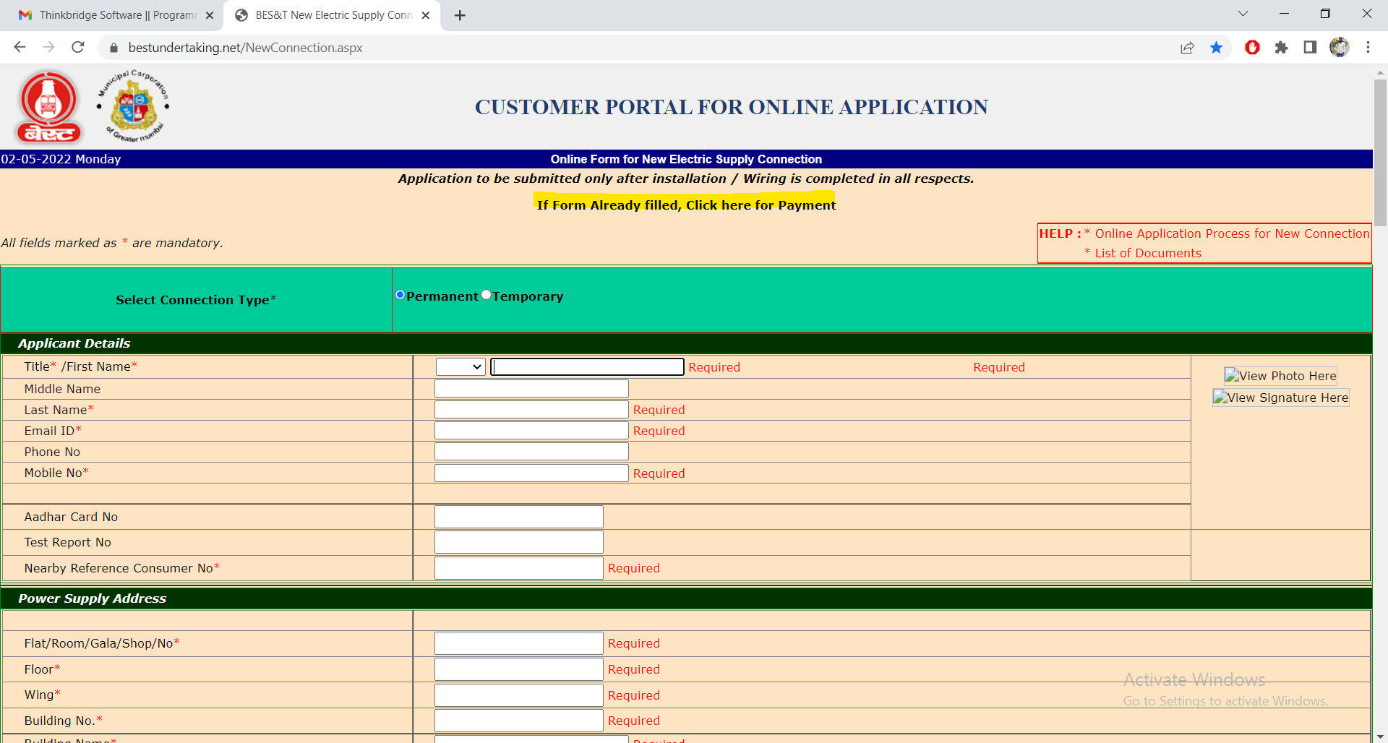

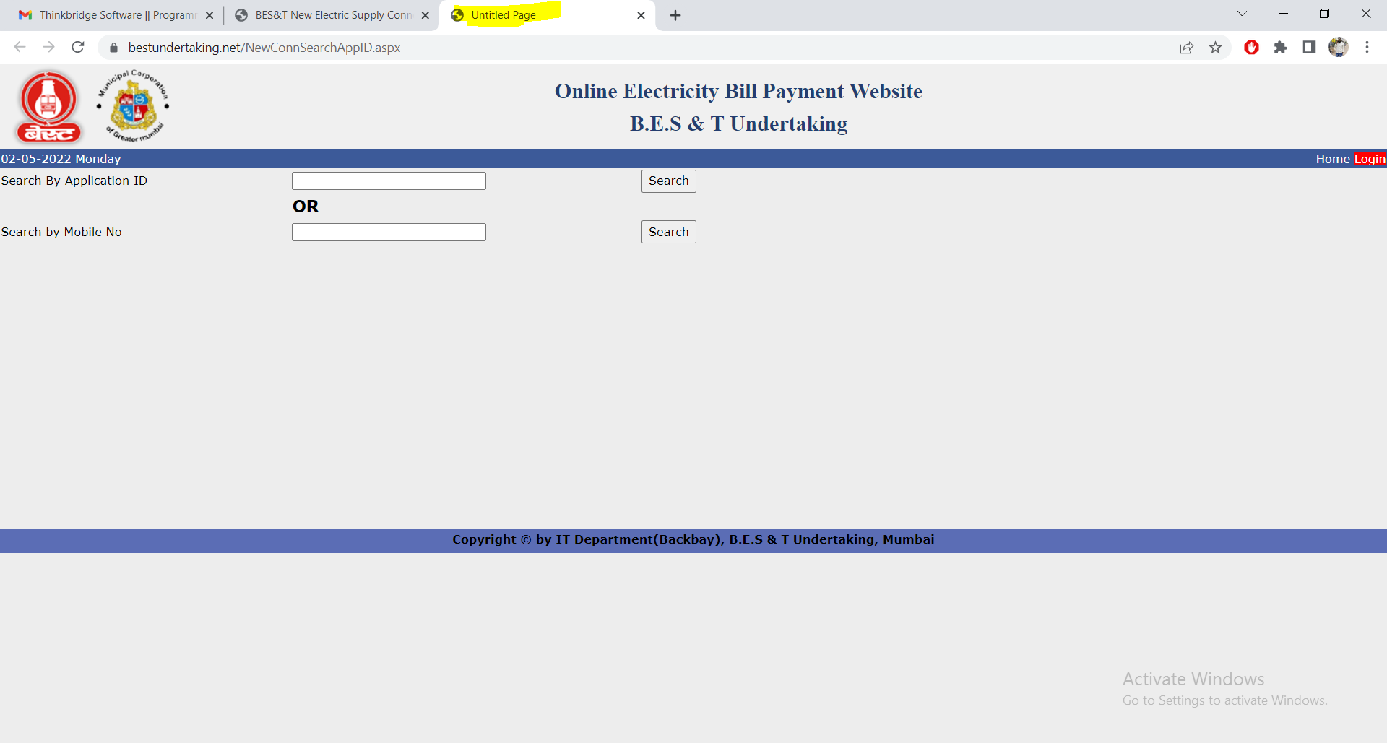

6) Instead of using Two Search button , we can go with single search button which would look good

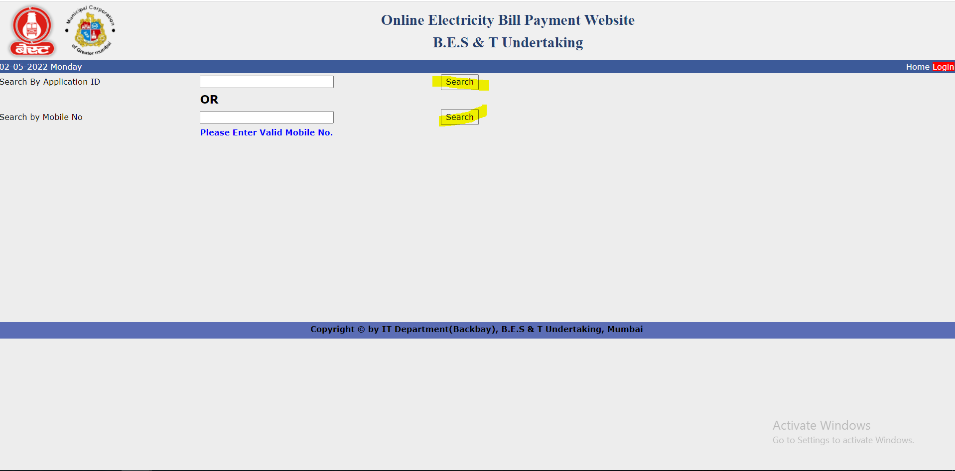

7) The contents can be either centered or right aligned (yes or No)

The green Label is not equal which is displayed in UI

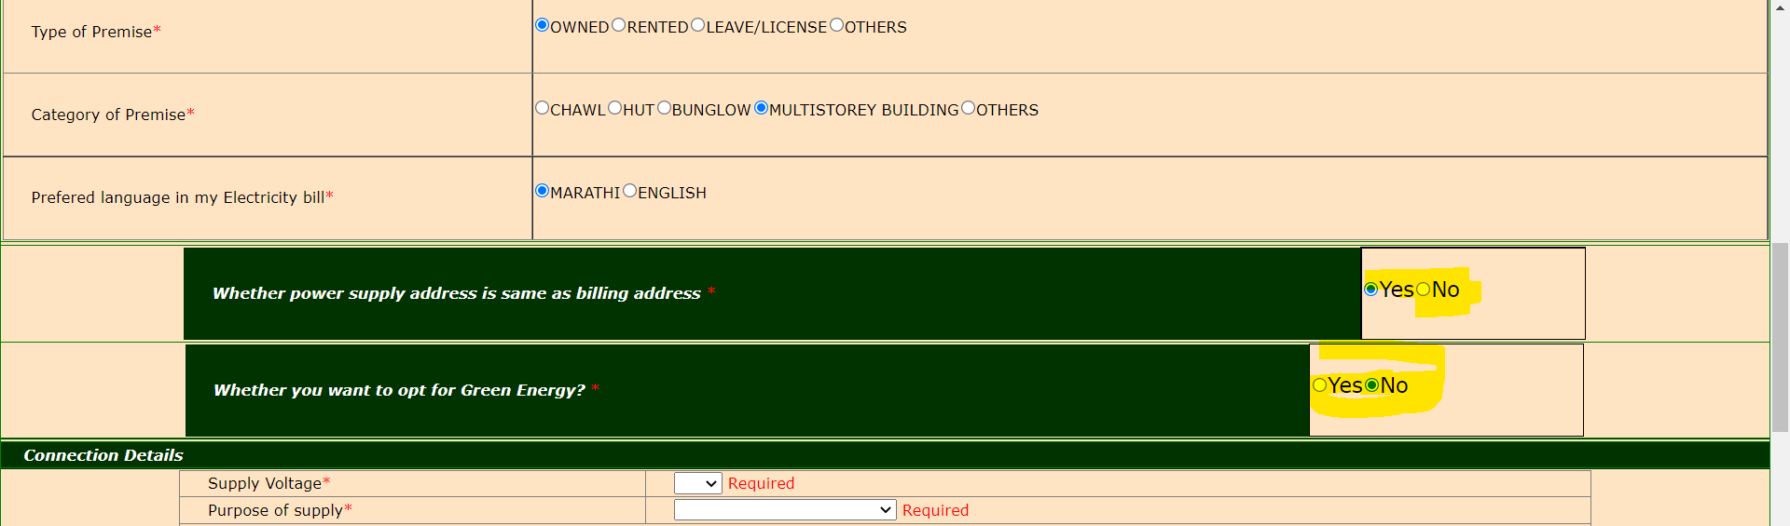

8) Technical error message not be displayed to user

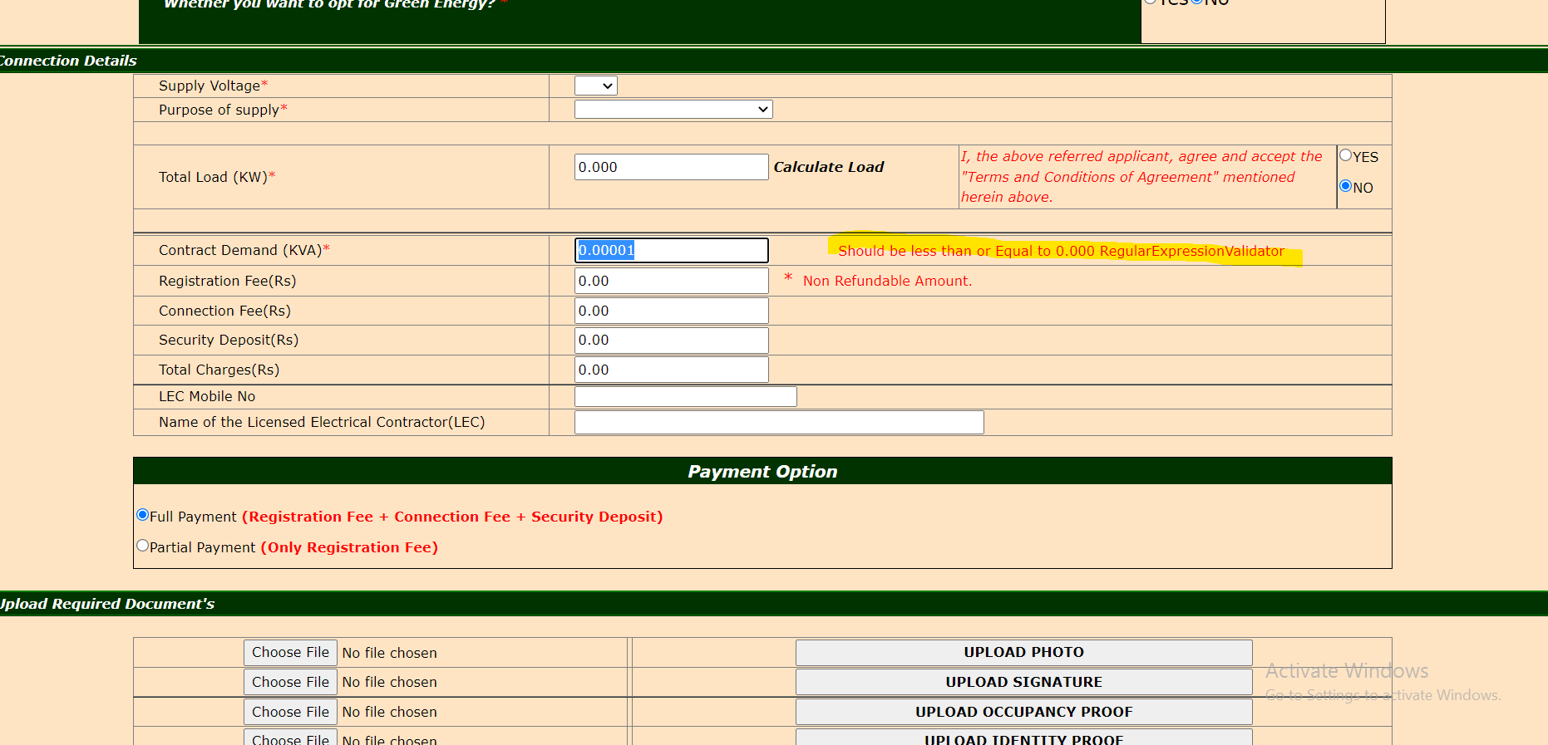

9) Too much of bottom space given below the webpage, instead of giving space at the bottom we can make use of that space in top and providing recent changes and updates to the customer who uses the application

